Facade Pattern
# Source: AI Source: Provided by: [Data Path: Persons Table -> ID Column: 1, Name_En Column: Motasem Essam] -> From: [ChatGPT] on [1/23/2026]
The Facade Pattern provides a simplified interface to a complex subsystem, making it easier for clients to interact with.
👉 Think of it like a TV remote: instead of adjusting each internal component (volume, channel, brightness) individually, you use one interface to control everything.

🔑 Key Points
# Source: AI Source: Provided by: [Data Path: Persons Table -> ID Column: 1, Name_En Column: Motasem Essam] -> From: [ChatGPT] on [1/23/2026]
• Hides complexity of subsystems
• Provides a high-level interface to simplify usage
• Promotes loose coupling between client and subsystem

❌ Bad Example
# Source: AI Source: Provided by: [Data Path: Persons Table -> ID Column: 1, Name_En Column: Motasem Essam] -> From: [ChatGPT] on [1/23/2026]
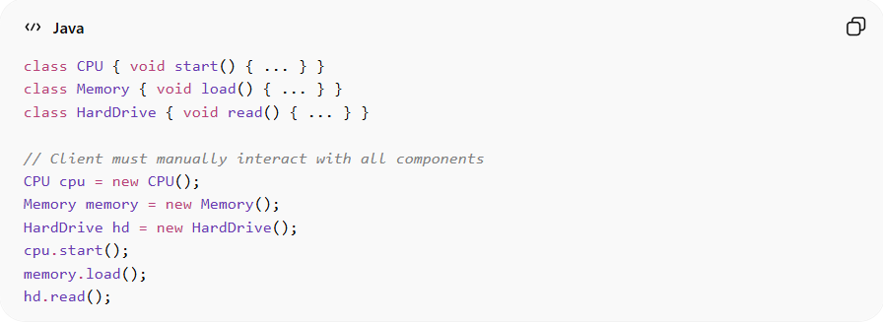
class CPU { void start() { ... } }
class Memory { void load() { ... } }
class HardDrive { void read() { ... } }

// Client must manually interact with all components
CPU cpu = new CPU();
Memory memory = new Memory();
HardDrive hd = new HardDrive();
cpu.start();
memory.load();
hd.read();
Problems:
• Client must understand internal subsystem details
• Increases complexity and dependency
• Violates Separation of Concerns

✅ Good Example
# Source: AI Source: Provided by: [Data Path: Persons Table -> ID Column: 1, Name_En Column: Motasem Essam] -> From: [ChatGPT] on [1/23/2026]
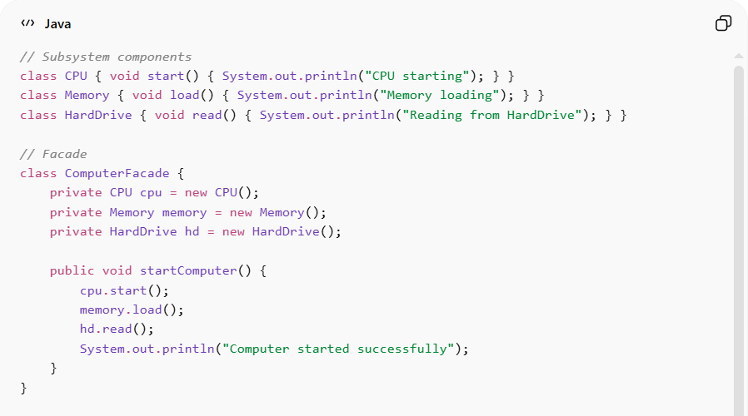
// Subsystem components
class CPU { void start() { System.out.println("CPU starting"); } }
class Memory { void load() { System.out.println("Memory loading"); } }
class HardDrive { void read() { System.out.println("Reading from HardDrive"); } }

// Facade
class ComputerFacade {
private CPU cpu = new CPU();
private Memory memory = new Memory();
private HardDrive hd = new HardDrive();

public void startComputer() {
cpu.start();
memory.load();
hd.read();
System.out.println("Computer started successfully");
}
}

// Client usage
ComputerFacade computer = new ComputerFacade();
computer.startComputer();
Benefits:
• Simplifies client interaction with complex subsystems
• Reduces dependency on internal classes
• Promotes loose coupling
• Improves readability and maintainability

⚡ Advantages
# Source: AI Source: Provided by: [Data Path: Persons Table -> ID Column: 1, Name_En Column: Motasem Essam] -> From: [ChatGPT] on [1/23/2026]
• Provides simple and unified interface
• Hides complexity of subsystems
• Reduces client-subsystem coupling
• Makes system easier to use and maintain

⚠️ Disadvantages
# Source: AI Source: Provided by: [Data Path: Persons Table -> ID Column: 1, Name_En Column: Motasem Essam] -> From: [ChatGPT] on [1/23/2026]
• Can become a god object if too many responsibilities are added
• Adds extra layer that may hide important functionality
• Subsystem still exists; Facade only simplifies access

🛠️ Use Cases
# Source: AI Source: Provided by: [Data Path: Persons Table -> ID Column: 1, Name_En Column: Motasem Essam] -> From: [ChatGPT] on [1/23/2026]
• Complex libraries or frameworks – providing simple APIs
• Home automation systems – unified control for lights, AC, alarms
• Startup/shutdown sequences – computers, software systems, servers
• Payment processing – unified interface for multiple payment gateways

